UNIT-III

FREQUENCY RESPONSE ANALYSIS

Whatis Frequency Response?
The response of a system can be partitioned into both the transient response and the steady state response. We can find the transient response by using Fourier integrals. The steady state response of a system for an input sinusoidal signal is known as the frequency response. In this chapter, we will focus only on the steady state response.
If a sinusoidal signal is applied as an input to a Linear Time-Invariant (LTI) system, then it produces the steady state output, which is also a sinusoidal signal. The input and output sinusoidal signals have the same frequency, but different amplitudes and phase angles. Let the input signal be
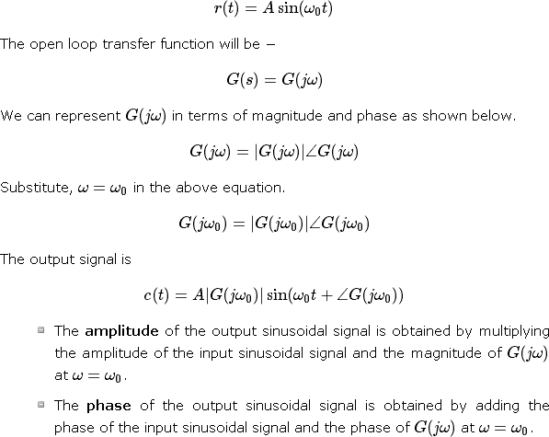
Where,
  - A is the amplitude of the input sinusoidal signal.
  - ω0 is angular frequency of the input sinusoidal signal. We can write, angular frequency ω0 as shown below.

ω0=2πf0

Here, f0 is the frequency of the input sinusoidal signal. Similarly, you can follow the same procedure for closed loop control system.

Frequency Domain Specifications
The frequency domain specifications are

Resonant peak
  - Resonant frequency
  - Bandwidth.
Consider the transfer function of the second order closed control system as
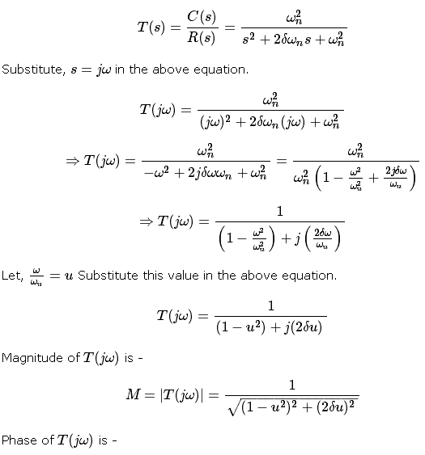
CONTROL SYSTEMS

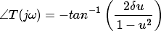

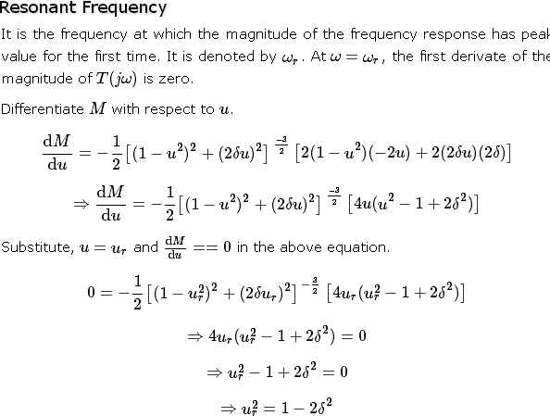

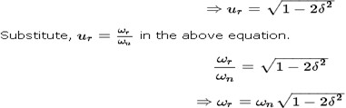

Resonant Peak
It is the peak (maximum) value of the magnitude of T(jω). It is denoted by Mr. At u=u_{r}, the Magnitude of T(jω) is -

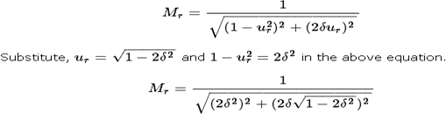

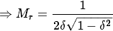

Resonant peak in frequency response corresponds to the peak overshoot in the time domain transient response for certain values of damping ratio δδ. So, the resonant peak and peak overshoot are correlated to each other.

Bandwidth
It is the range of frequencies over which, the magnitude of T(jω) drops to 70.7% from its zero frequency value.
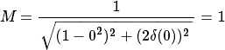
At ω=0, the value of u will be zero. Substitute, u=0 in M.
Therefore, the magnitude of T(jω) is one at ω=0
At 3-dB frequency, the magnitude of T(jω) will be 70.7% of magnitude of T(jω)) at ω=0
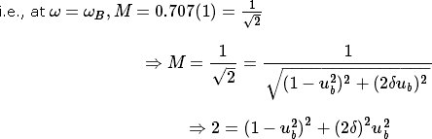

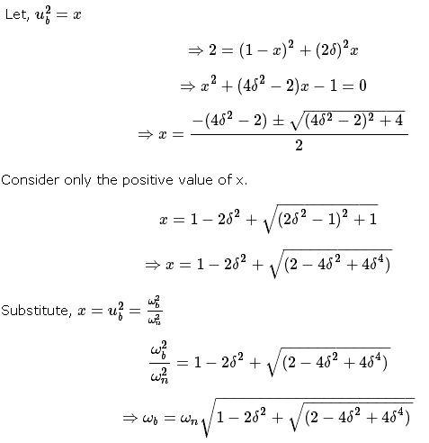
Bandwidth ωb in the frequency response is inversely proportional to the rise time tr in the time domain transient response.

Bode plots
The Bode plot or the Bode diagram consists of two plots −

  - Magnitude plot
  - Phase plot
In both the plots, x-axis represents angular frequency (logarithmic scale). Whereas, yaxis represents the magnitude (linear scale) of open loop transfer function in the magnitude plot and the phase angle (linear scale) of the open loop transfer function in the phase plot.
The magnitude of the open loop transfer function in dB is -

The phase angle of the open loop transfer function in degrees is -

Basic of Bode Plots
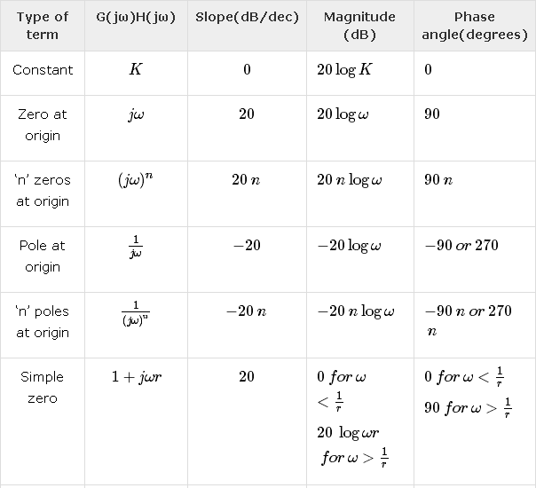
The following table shows the slope, magnitude and the phase angle values of the terms present in the open loop transfer function. This data is useful while drawing the Bode plots.

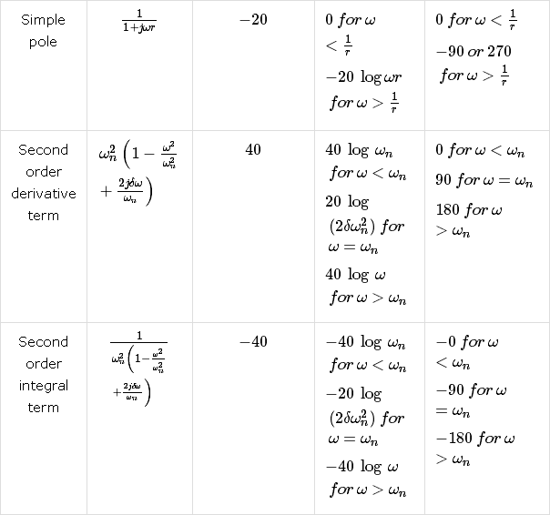

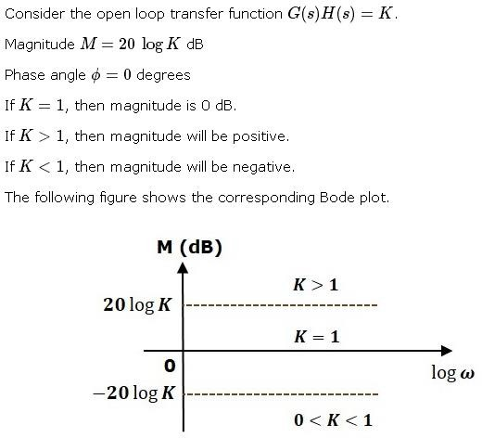

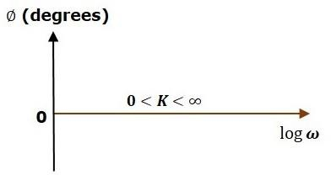

The magnitude plot is a horizontal line, which is independent of frequency. The 0 dB line itself is the magnitude plot when the value of K is one. For the positive values of K, the horizontal line will shift 20logK dB above the 0 dB line. For the negative values of K, the horizontal line

will shift 20logK dB below the 0 dB line. The Zero degrees line itself is the phase plot for all the positive values of K.
Consider the open loop transfer function G(s)H(s)=s Magnitude M=20logω dB
Phase angle ϕ=90⁰
At ω=0.1rad/sec, the magnitude is -20 dB. At ω=1rad/sec, the magnitude is 0 dB.
At ω=10 rad/sec, the magnitude is 20 dB.
The following figure shows the corresponding Bode plot.
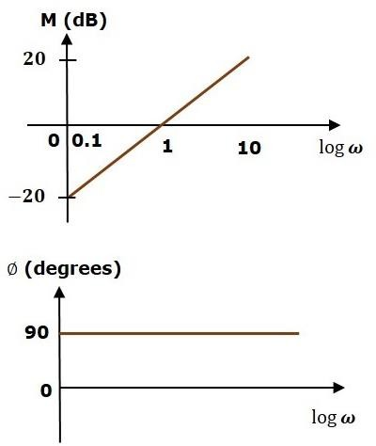

The magnitude plot is a line, which is having a slope of 20 dB/dec. This line started at ω=0.1rad/sec having a magnitude of -20 dB and it continues on the same slope. It is touching 0 dB line at ω=1 rad/sec. In this case, the phase plot is 90⁰ line.
Consider the open loop transfer function G(s)H(s)=1+sτ. Magnitude

Phase angle

For , the magnitude is 0 dB and phase angle is 0 degrees.

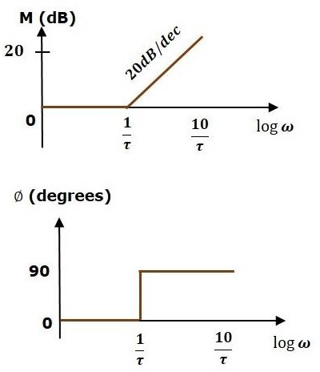
For , the magnitude is 20logωτ dB and phase angle is 90⁰. The following figure shows the corresponding Bode plot

The magnitude plot is having magnitude of 0 dB upto ω=1τω=1τ rad/sec. From ω=1τ rad/sec, it is having a slope of 20 dB/dec. In this case, the phase plot is having phase angle of 0 degrees up to ω=1τ rad/sec and from here, it is having phase angle of 90⁰. This Bode plot is called the asymptotic Bode plot.
As the magnitude and the phase plots are represented with straight lines, the Exact Bode plots resemble the asymptotic Bode plots. The only difference is that the Exact Bode plots will have simple curves instead of straight lines.

Similarly, you can draw the Bode plots for other terms of the open loop transfer function which are given in the table.

Rules for Construction of Bode Plots
Follow these rules while constructing a Bode plot.
  - Represent the open loop transfer function in the standard time constant form.
  - Substitute, s=jωs=jω in the above equation.
  - Find the corner frequencies and arrange them in ascending order.
  - Consider the starting frequency of the Bode plot as 1/10th of the minimum corner frequency or 0.1 rad/sec whichever is smaller value and draw the Bode plot upto 10 times maximum corner frequency.
  - Draw the magnitude plots for each term and combine these plots properly.
  - Draw the phase plots for each term and combine these plots properly.
Note − The corner frequency is the frequency at which there is a change in the slope of the magnitude plot.
Example
Consider the open loop transfer function of a closed loop control syste
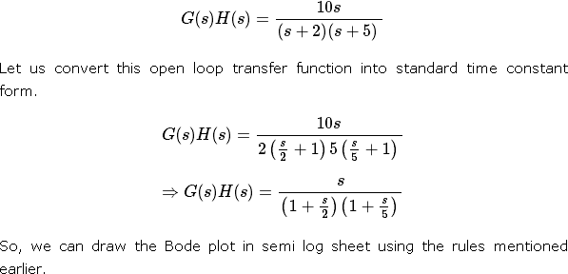

Stability Analysis using Bode Plots
From the Bode plots, we can say whether the control system is stable, marginally stable or unstable based on the values of these parameters.

  - Gain cross over frequency and phase cross over frequency
  - Gain margin and phase margin

Phase Cross over Frequency
The frequency at which the phase plot is having the phase of -180⁰ is known as phase cross over frequency. It is denoted by ωpc. The unit of phase cross over frequency is rad/sec.
Gain Cross over Frequency
The frequency at which the magnitude plot is having the magnitude of zero dB is known as gain cross over frequency. It is denoted by ωgc. The unit of gain cross over frequency is rad/sec.
The stability of the control system based on the relation between the phase cross over frequency and the gain cross over frequency is listed below.
  - If the phase cross over frequency ωpc is greater than the gain cross over frequency ωgc, then the control system is stable.
  - If the phase cross over frequency ωpc is equal to the gain cross over frequency ωgc, then the control system is marginally stable.
  - If the phase cross over frequency ωpcis less than the gain cross over frequency ωgc, then the control system is unstable.

Gain Margin
Gain margin GMGM is equal to negative of the magnitude in dB at phase cross over frequency.
GM=20log(1Mpc)=20logMpc

Where, MpcMpc is the magnitude at phase cross over frequency. The unit of gain margin (GM) is dB.

Phase Margin
The formula for phase margin PMPM is
PM=180⁰+ϕgc

Where, ϕgc is the phase angle at gain cross over frequency. The unit of phase margin is degrees.


NOTE:

The stability of the control system based on the relation between gain margin and phase margin is listed below.
  - If both the gain margin GM and the phase margin PM are positive, then the control system is stable.
  - If both the gain margin GM and the phase margin PM are equal to zero, then the control system is marginally stable.
If the gain margin GM and / or the phase margin PM are/is negative, then the control system is unstable.

Polar plots
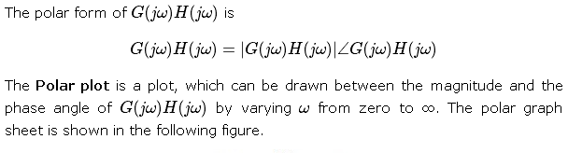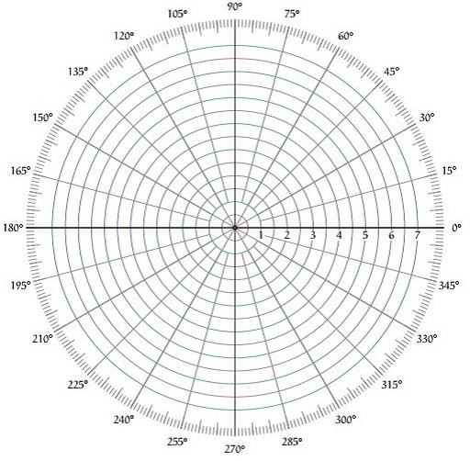Polar plot is a plot which can be drawn between magnitude and phase. Here, the magnitudes are represented by normal values only.

This graph sheet consists of concentric circles and radial lines. The concentric circles and the radial lines represent the magnitudes and phase angles respectively. These angles are represented by positive values in anti-clock wise direction. Similarly, we can represent angles with negative values in clockwise direction. For example, the angle 270⁰ in anti-clock wise direction is equal to the angle −90⁰ in clockwise direction.

Rules for Drawing Polar Plots
Follow these rules for plotting the polar plots.
  - Substitute, s=jω in the open loop transfer function.
  - Write the expressions for magnitude and the phase of G(jω)H(jω)
  - Find the starting magnitude and the phase of G(jω)H(jω) by substituting ω=0. So, the polar plot starts with this magnitude and the phase angle.
  - Find the ending magnitude and the phase of G(jω)H(jω) by substituting ω=∞ So, the polar plot ends with this magnitude and the phase angle.
  - Check whether the polar plot intersects the real axis, by making the imaginary term of G(jω)H(jω) equal to zero and find the value(s) of ω.
  - Check whether the polar plot intersects the imaginary axis, by making real term of G(jω)H(jω) equal to zero and find the value(s) of ω.
  - For drawing polar plot more clearly, find the magnitude and phase of G(jω)H(jω) by considering the other value(s) of ω.

Example
Consider the open loop transfer function of a closed loop control system.
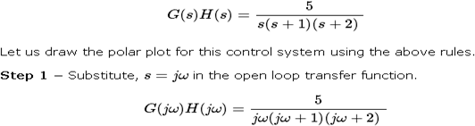
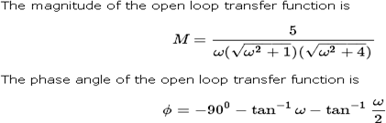

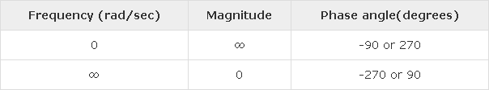

So, the polar plot starts at (∞,−90⁰) and ends at (0,−270⁰). The first and the second terms within the brackets indicate the magnitude and phase angle respectively.
Step 3 − Based on the starting and the ending polar co-ordinates, this polar plot will intersect the negative real axis. The phase angle corresponding to the negative real axis is −180⁰ or 180⁰. So, by equating the phase angle of the open loop transfer function to either −180⁰ or 180⁰, we will get the ω value as √2.
By substituting ω=√2 in the magnitude of the open loop transfer function, we will get M=0.83. Therefore, the polar plot intersects the negative real axis when ω=√2 and the polar coordinate is (0.83,−180⁰).
So, we can draw the polar plot with the above information on the polar graph sheet.

Nyquist Plots
Nyquist plots are the continuation of polar plots for finding the stability of the closed loop control systems by varying ω from −∞ to ∞. That means, Nyquist plots are used to draw the complete frequency response of the open loop transfer function.

Nyquist Stability Criterion
The Nyquist stability criterion works on the principle of argument. It states that if there are P poles and Z zeros are enclosed by the ‘s’ plane closed path, then the corresponding G(s)H(s)G(s)H(s) plane must encircle the origin P−ZP−Z times. So, we can write the number of encirclements N as,
N=P−ZN=P−Z

  - If the enclosed ‘s’ plane closed path contains only poles, then the direction of the encirclement in the G(s)H(s)G(s)H(s) plane will be opposite to the direction of the enclosed closed path in the ‘s’ plane.
  - If the enclosed ‘s’ plane closed path contains only zeros, then the direction of the encirclement in the G(s)H(s)G(s)H(s) plane will be in the same direction as that of the enclosed closed path in the ‘s’ plane.

Let us now apply the principle of argument to the entire right half of the ‘s’ plane by selecting it as a closed path. This selected path is called the Nyquist contour.
We know that the closed loop control system is stable if all the poles of the closed loop transfer function are in the left half of the ‘s’ plane. So, the poles of the closed loop transfer function are nothing but the roots of the characteristic equation. As the order of the characteristic equation increases, it is difficult to find the roots. So, let us correlate these roots of the characteristic equation as follows.
  - The Poles of the characteristic equation are same as that of the poles of the open loop transfer function.
  - The zeros of the characteristic equation are same as that of the poles of the closed loop transfer function.
We know that the open loop control system is stable if there is no open loop pole in the the right half of the ‘s’ plane.
i.e.,P=0⇒N=−ZP=0⇒N=−Z
We know that the closed loop control system is stable if there is no closed loop pole in the right half of the ‘s’ plane.
i.e.,Z=0⇒N=PZ=0⇒N=P
Nyquist stability criterion states the number of encirclements about the critical point (1+j0) must be equal to the poles of characteristic equation, which is nothing but the poles of the open loop transfer function in the right half of the ‘s’ plane. The shift in origin to (1+j0) gives the characteristic equation plane.

Rules for Drawing Nyquist Plots
Follow these rules for plotting the Nyquist plots.
  - Locate the poles and zeros of open loop transfer function G(s)H(s) in ‘s’ plane.
  - Draw the polar plot by varying ω from zero to infinity. If pole or zero present at s = 0, then varying ω from 0+ to infinity for drawing polar plot.
  - Draw the mirror image of above polar plot for values of ω ranging from −∞ to zero (0⁻ if any pole or zero present at s=0).
  - The number of infinite radius half circles will be equal to the number of poles or zeros at origin. The infinite radius half circle will start at the point where the mirror image of the polar plot ends. And this infinite radius half circle will end at the point where the polar plot starts.

After drawing the Nyquist plot, we can find the stability of the closed loop control system using the Nyquist stability criterion. If the critical point (-1+j0) lies outside the encirclement, then the closed loop control system is absolutely stable.

Stability Analysis using Nyquist Plots
From the Nyquist plots, we can identify whether the control system is stable, marginally stable or unstable based on the values of these parameters.

  - Gain cross over frequency and phase cross over frequency
  - Gain margin and phase margin

Phase Cross over Frequency
The frequency at which the Nyquist plot intersects the negative real axis (phase angle is 180⁰) is known as the phase cross over frequency. It is denoted by ωpc.

Gain Cross over Frequency
The frequency at which the Nyquist plot is having the magnitude of one is known as the gain cross over frequency. It is denoted by ωgc.
The stability of the control system based on the relation between phase cross over frequency and gain cross over frequency is listed below.
  - If the phase cross over frequency ωpc is greater than the gain cross over frequency ωgc, then the control system is stable.
  - If the phase cross over frequency ωpc is equal to the gain cross over frequency ωgc, then the control system is marginally stable.
  - If phase cross over frequency ωpc is less than gain cross over frequency ωgc, then the control system is unstable.

Gain Margin
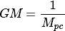
The gain margin GM is equal to the reciprocal of the magnitude of the Nyquist plot at the phase cross over frequency.
Where, Mpc is the magnitude in normal scale at the phase cross over frequency.

Phase Margin
The phase margin PM is equal to the sum of 180⁰ and the phase angle at the gain cross over frequency.

PM=180⁰+ϕgc

Where, ϕgc is the phase angle at the gain cross over frequency.

The stability of the control system based on the relation between the gain margin and the phase margin is listed below.
  - If the gain margin GM is greater than one and the phase margin PM is positive, then the control system is stable.
  - If the gain margin GMs equal to one and the phase margin PM is zero degrees, then the control system is marginally stable.
  - If the gain margin GM is less than one and / or the phase margin PM is negative, then the control system is unstable.

